Pojo-Servlet-JSP-Hibernate flow:
Pojo is Model
JSP/Servlet – View
Servlet/JSP – Controller
Hibernate as DAO
Request/Response pojo pojo
DAO
Browser
HTML as view
DB
Controller

Browser

Dependency Management
Object Management
Configuration Management

pom.xml/ or application properties as parameter (many objects like models
add “jars” as buildpath (many xmls, or annotations) (pojos), Views(HTML),
Controllers(servlets), DAOs)
Server

------------------------------------2. Fetch All Users as Admin------------------------------------------------------------
Browser

1. request
Index.jsp
DB
/login
9. response
2.GET
login.jsp
fetchallusers.jsp
8. HyperLink/GET
Web.xml
3.POST
4. pojo
UserDao
Servlet mapping 7. Success
hibernate.cfg.xml & pojo-hbm.xml/annotation
.
url-servlet 5.pojo validate 6. Success
Server
DB info &
mapping
pojo-table

Hibernate with servlet and JSP

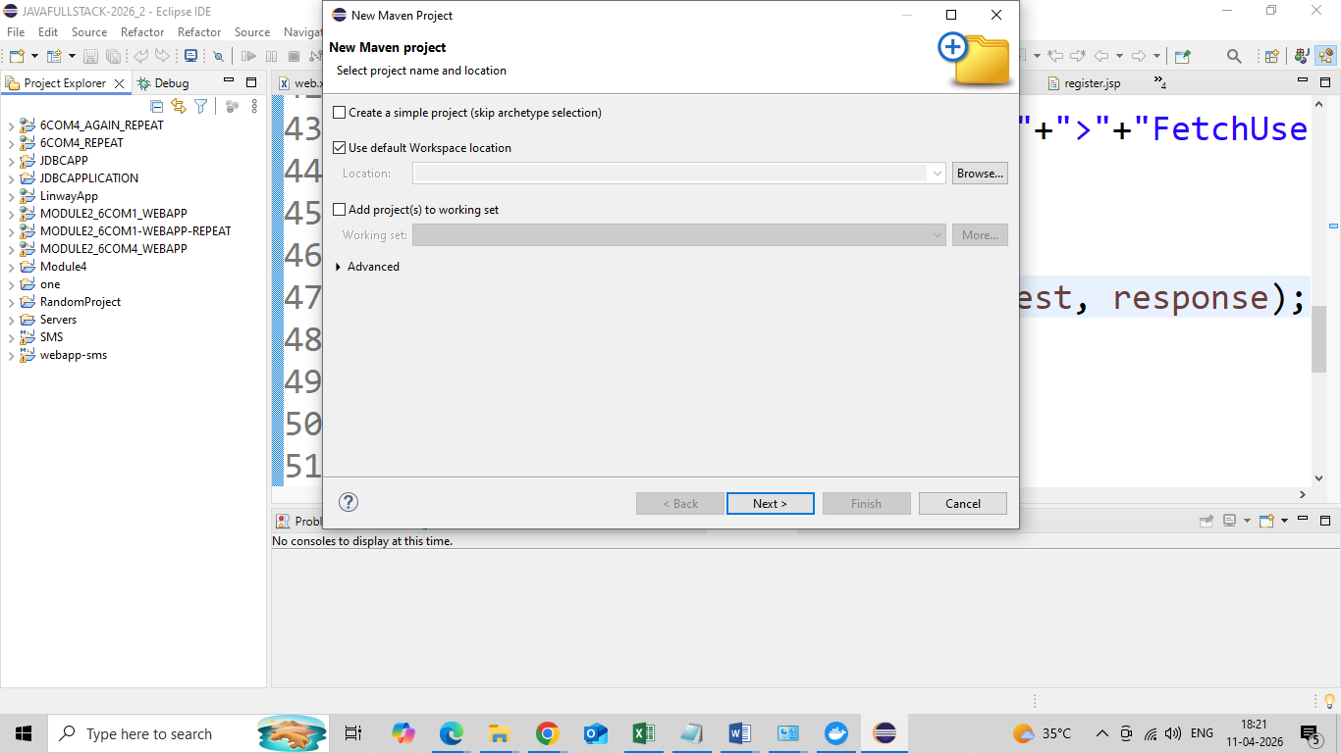

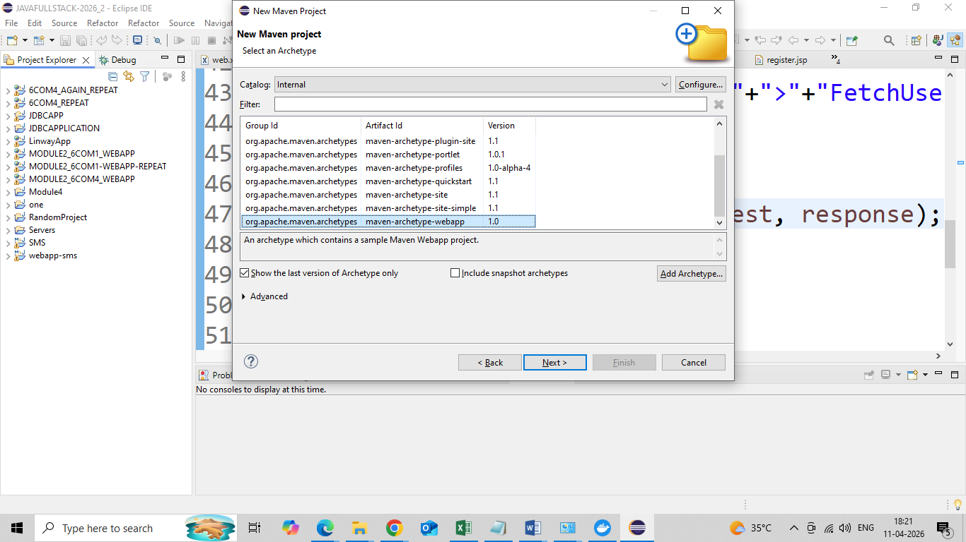

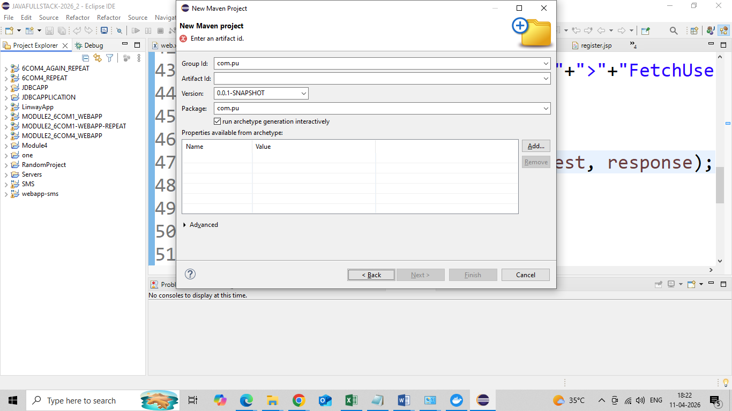

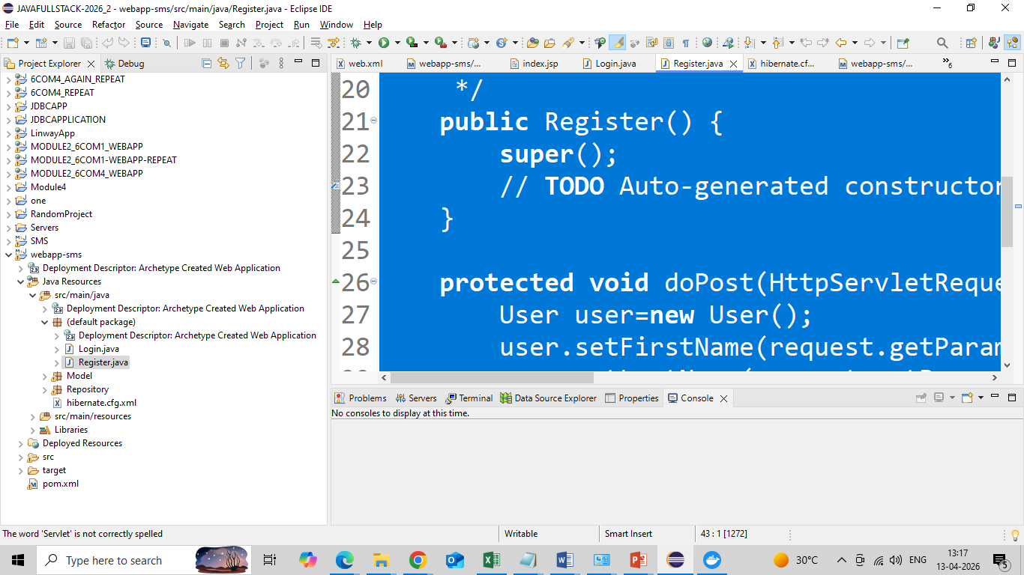
All jsp must be created under webapp folder (rightclick).

index.jsp

<html>
<body>
<center>
<h2>Hello User!</h2><br><br>
<h2>Home</h2>
<a href="register.jsp">Register Here</a>
<a href="login.jsp">Login Here</a>
</center>
</body>
</html>

login.jsp

<%@ page language="java" contentType="text/html; charset=UTF-8"
pageEncoding="UTF-8"%>
<!DOCTYPE html>
<html>
<head>
<meta charset="UTF-8">
<title>Insert title here</title>
</head>
<body>
<center>
<form action="login" method="post">
UserName <input type="text" name="un"><br><br>
Password <input type="password" name="pwd"><br><br>
<input type="submit" value="login">
</form>
</body>
</html>

fetchallusers.jsp

<%@ page language="java" contentType="text/html; charset=UTF-8"
pageEncoding="UTF-8"%>
<%@ page import= "java.util.*" %>
<%@ page import="Repository.UserDAO" %>
<%@ page import="Model.User" %>
<%@ page import="java.util.ListIterator" %>
<!DOCTYPE html>
<html>
<head>
<meta charset="UTF-8">
<title>Insert title here</title>
</head>
<body>
<center>
<h2> User Fetched </h2>
<%
UserDAO userDao=new UserDAO();
List<User> users=userDao.fetchAll();
ListIterator itr=users.listIterator();
%>

<table border=2">
<tr>
<th>First Name</th>
<th>Last Name</th>
<th>User Name</th>
</tr>
<% while(itr.hasNext()) {
User user=(User)itr.next();%>
<tr>
<td><% out.print(user.getFirstName()); %></td>
<td><% out.print(user.getLastName());%></td>
<td><% out.print(user.getUsername()); %></td>
</tr>
<%} %>
</table>
</center>
</body>
</html>

All Servlets must be created inside classes folder inside webapp/WEB-INF
Right click, Create folder classes, select classes folder -> right click-> servlet
Give name Login, Select doPost

import java.io.IOException;
import javax.servlet.ServletException;
import javax.servlet.http.HttpServlet;
import javax.servlet.http.HttpServletRequest;
import javax.servlet.http.HttpServletResponse;

import Model.User;
import Repository.UserDAO;

/**
* Servlet implementation class Login
*/
public class Login extends HttpServlet {

protected void doPost(HttpServletRequest request, HttpServletResponse response) throws ServletException, IOException {

response.setContentType("text/html");
//database logic
String name=request.getParameter("un");
String pwd=request.getParameter("pwd");
UserDAO dao=new UserDAO();
User user=dao.validate(name, pwd);
if(user!=null) {
request.getRequestDispatcher("login.jsp").include(request, response);
response.getWriter().println("<center>");
response.getWriter().println("<h2>");
response.getWriter().println("Welcome Admin");
response.getWriter().println("<br><br>");
response.getWriter().println("<a href="+"fetchallusers.jsp"+">"+"FetchUsers"+"</a>");
response.getWriter().println("</h2>");
response.getWriter().println("</center>");
}else {
request.getRequestDispatcher("login.jsp").include(request, response);
response.getWriter().println("<center>");
response.getWriter().println("<h2>");
response.getWriter().println("Login Failed");
response.getWriter().println("</h2>");
response.getWriter().println("</center>");
}
}

}

Create two packages under src/main/java
Name them Model and Repository
All pojo must be created under Model package
package Model;
import java.io.Serializable;

import javax.persistence.Column;
import javax.persistence.Entity;
import javax.persistence.GeneratedValue;
import javax.persistence.GenerationType;
import javax.persistence.Id;

@Entity
public class User implements Serializable {

@Id
@GeneratedValue(strategy = GenerationType.AUTO)
private int id;

@Column
private String firstName;

@Column
private String lastName;

@Column
private String username;

@Column
private String password;

public String getFirstName() {
return firstName;
}
public void setFirstName(String firstName) {
this.firstName = firstName;
}
public String getLastName() {
return lastName;
}
public void setLastName(String lastName) {
this.lastName = lastName;
}
public String getUsername() {
return username;
}
public void setUsername(String username) {
this.username = username;
}
public String getPassword() {
return password;
}
public void setPassword(String password) {
this.password = password;
}
public User(int id, String firstName, String lastName, String username, String password) {
super();
this.id = id;
this.firstName = firstName;
this.lastName = lastName;
this.username = username;
this.password = password;
}
public User() {
super();
}

}

All DAO must be under Repository package
package Repository;
import java.util.List;

import org.hibernate.Session;
import org.hibernate.SessionFactory;
import org.hibernate.Transaction;
import org.hibernate.cfg.Configuration;

import Model.User;

public class UserDAO {
Configuration configuration=null;
SessionFactory sessionFactory=null;
Session session=null;
public UserDAO() {
//1. create Configuration object
configuration=new Configuration().configure().addAnnotatedClass(User.class);
//2. create Session Factory object
sessionFactory=configuration.buildSessionFactory();
//3. Create Session object
session=sessionFactory.openSession();
}
public void saveUser(User user) {
//4. Begin your transaction
Transaction transaction=session.beginTransaction();
//5.Save your object to database
session.save(user);

System.out.println("Saved");
//6. Commit your transaction
transaction.commit();
session.close();
sessionFactory.close();
}
public User validate(String name, String password) {
Transaction transaction = session.beginTransaction();
String hql="from User where username=:un and password=:p";
User user=session.createQuery(hql,User.class)
.setParameter("un", name)
.setParameter("p",password)
.uniqueResult();
transaction.commit();
return user;
}
public List<User> fetchAll() {
Transaction transaction=session.beginTransaction();
return session.createQuery("from User",User.class).list();
}

}

Hibernate.cfg.xml must be created under src/main/java by rightclick-> file

Hibernate.cfg.xml

<?xml version="1.0" encoding="utf-8"?>
<!DOCTYPE hibernate-configuration PUBLIC
"-//Hibernate/Hibernate Configuration DTD 3.0//EN"
"http://www.hibernate.org/dtd/hibernate-configuration-3.0.dtd">

<hibernate-configuration>
<session-factory>
<property name="hibernate.connection.driver_class">com.mysql.jdbc.Driver</property>
<property name="hibernate.connection.url">jdbc:mysql://localhost:3306/test</property>
<property name="hibernate.connection.username">root</property>
<property name="hibernate.connection.password">root</property>
<property name="hibernate.dialect">org.hibernate.dialect.MySQL8Dialect</property>
<property name="show_sql">true</property>
<property name="format_sql">true</property>
<property name="hbm2ddl.auto">update</property>
</session-factory>
</hibernate-configuration>

web.xml
<!DOCTYPE web-app PUBLIC
"-//Sun Microsystems, Inc.//DTD Web Application 2.3//EN"
"http://java.sun.com/dtd/web-app_2_3.dtd" >

<web-app>
<display-name>Archetype Created Web Application</display-name>

<servlet>
<servlet-name>Register</servlet-name>
<servlet-class>Register</servlet-class>
</servlet>
<servlet-mapping>
<servlet-name>Register</servlet-name>
<url-pattern>/register</url-pattern>
</servlet-mapping>
<servlet>
<servlet-name>Login</servlet-name>
<servlet-class>Login</servlet-class>
</servlet>
<servlet-mapping>
<servlet-name>Login</servlet-name>
<url-pattern>/login</url-pattern>
</servlet-mapping>
</web-app>

pom.xml for dependency management
<project xmlns="http://maven.apache.org/POM/4.0.0" xmlns:xsi="http://www.w3.org/2001/XMLSchema-instance"
xsi:schemaLocation="http://maven.apache.org/POM/4.0.0 http://maven.apache.org/maven-v4_0_0.xsd">
<modelVersion>4.0.0</modelVersion>
<groupId>com.pu</groupId>
<artifactId>webapp-sms</artifactId>
<packaging>war</packaging>
<version>0.0.1-SNAPSHOT</version>
<name>webapp-sms Maven Webapp</name>
<url>http://maven.apache.org</url>
<dependencies>

<dependency>
<groupId>junit</groupId>
<artifactId>junit</artifactId>
<version>3.8.1</version>
<scope>test</scope>
</dependency>
<dependency>
<groupId>org.hibernate</groupId>
<artifactId>hibernate-core</artifactId>
<version>5.6.7.Final</version>
<scope>compile</scope>
</dependency>
<dependency>
<groupId>javax.servlet</groupId>
<artifactId>javax.servlet-api</artifactId>
<version>4.0.1</version>
<scope>provided</scope>
</dependency>
<dependency>
<groupId>javax.servlet.jsp</groupId>
<artifactId>javax.servlet.jsp-api</artifactId>
<version>2.3.3</version>
<scope>provided</scope>
</dependency>
<dependency>
<groupId>mysql</groupId>
<artifactId>mysql-connector-java</artifactId>
<version>8.0.33</version>
<scope>compile</scope>
</dependency>

</dependencies>
<build>
<finalName>webapp-sms</finalName>
</build>
</project>

Run on Server (Preferably Tomcat 9)

